Sent via email

Dear President May,
Limerick City & County Council (LCCC) plans to construct a Greenway along the existing paved, gravel and desire line path between the University of Limerick Boat Club and Annacotty village. The new greenway will be a 3.5-4.0m wide tarmac path along the southern bank of the Shannon river and the western bank of the Mulcair river. There will also be new concrete footpaths and off-road cycle lanes along University Road and McLoughlin Drive linking the proposed greenway with existing cycle lanes on Plassey Park Rd. There will be new steel bridges at water crossings, and public lighting will be provided along the 6.8km total length of the greenway. New wooden and anti-climb fencing will be erected along the path for health and safety reasons near water or at steep slopes, or to prevent unauthorised access to the National Technology Park, historical buildings, and structures.
The purpose of the greenway is to provide a new off-road link between Annacotty and Limerick city. The greenway will be fully accessible to all users and the works will provide a new ramp to Plassey Beach so wheelchair and mobility scooter users, and parents with buggies can access the beach. This path will enable people to commute to the University and into the city by walking, running, or cycling and will help reduce car use for short journeys in Limerick. The Limerick Greenway has been a huge success and LCCC plans to build on that momentum and provide a city greenway which will become a key artery in the Limerick Shannon Metropolitan Area Transport Strategy (LSMATS) cycle network and the National Cycle Network. It is planned that this greenway will be part of the Limerick to Carrick on Shannon Corridor 11 which will see the construction of a new greenway that will cross the Mulcair river at the Bottomless Bridge and continue upstream along the edge of the Shannon river to Castleconnell, Montpelier, and onward to County Tipperary. This greenway will also link to a Waterways Ireland planned path along the Blackwater river/ Errina canal in County Clare between Castletroy and Killaloe, and onwards to Scarriff.
LCCC engaged Ryan Hanley Consulting Engineers to produce the Preliminary design, Route selection, Constraints study, and Detailed Design, carry out ground, topographical, and ecological surveys, produce an Appropriate Assessment screening report, a Natura Impact Statement, an Environmental Impact Assessment report, and we are currently engaging with An Bord Pleanála in a pre-consultation phase before we plan to submit a planning application for the project.
We carried out a non-statutory public consultation event on 4th August 2022 which was attended by approximately 100 people including staff members from the University of Limerick. The Virtual Public Consultation room is accessible from this link https://www.innovision.ie/limerickcitygreenway
The people who attended were generally very positive about the greenway proposals. Some attendees expressed their concerns about a possible increase in anti-social behaviour outside their properties as a result of opening up the new greenway. We have included fencing, bollards, and stone walls in the design to prevent access to users who are not walkers, runners, or cyclists. The new fully accessible greenway will be safer than the existing path with less trip hazards and wider tarmac surface and bridges, and public lighting will be provided to enhance the safety of users. These measures should increase footfall along the greenway and passive monitoring should reduce anti-social behaviour.
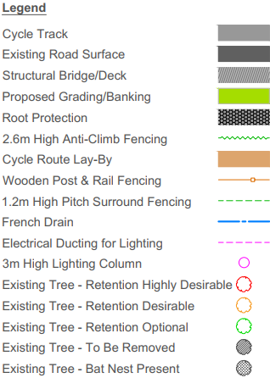
Attendees at the consultation event expressed their concerns about the impact of the proposed greenway on the environment in particular the mature trees along the riverbanks. Our environmental and ecology surveys included surveys for Bats, breeding and wintering Birds, Otters, Badgers, and Lampre, and we carried out a survey of the trees along the Shannon and Mulcair rivers. Our Arborist identified mature (shown in red outline on the drawings), semi-mature (orange outline), and immature (green outline) trees and we designed the greenway to avoid all mature trees and the majority of semi-mature trees. There will be tree removal required along the riverbanks and three new trees will replace every semi-mature and immature tree that will be cut down. We will construct a tree root protection layer along the riverside greenway to avoid excavating around tree roots. Our Bird and Bat surveys identified the location of roosts in mature trees, and these locations are in our general arrangement drawings to inform the greenway contractor to spend minimum amount of time in these areas. Example of the greenway where it avoids trees which require retention are provided below.
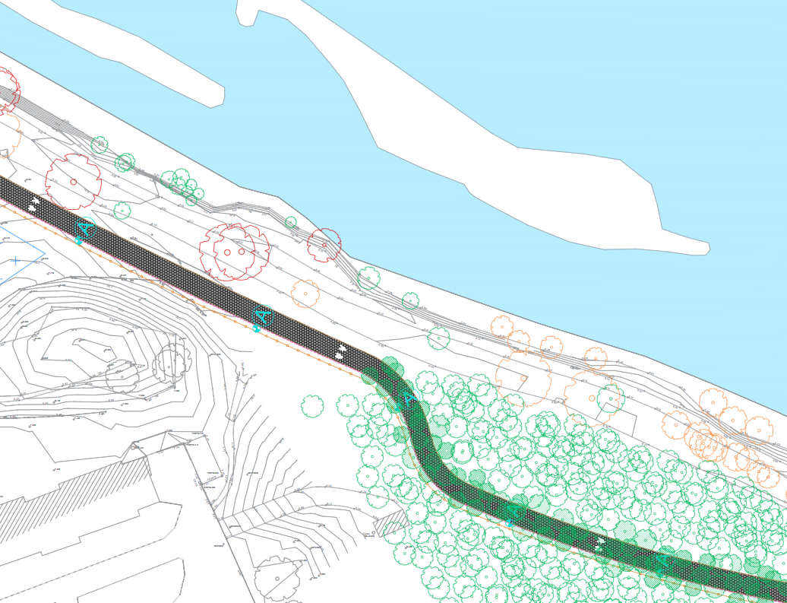
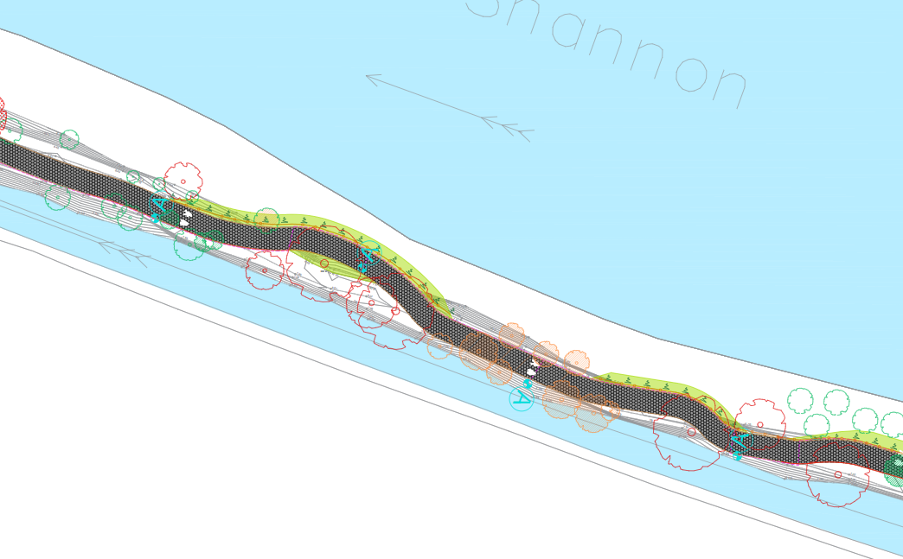
A bird roost and a bat roost in mature trees, the design of the greenway alignment to avoid the trees and roosts, and the area where three trees will be planted to compensate for each trees that will be cut down along the greenway route, are shown in the image below.
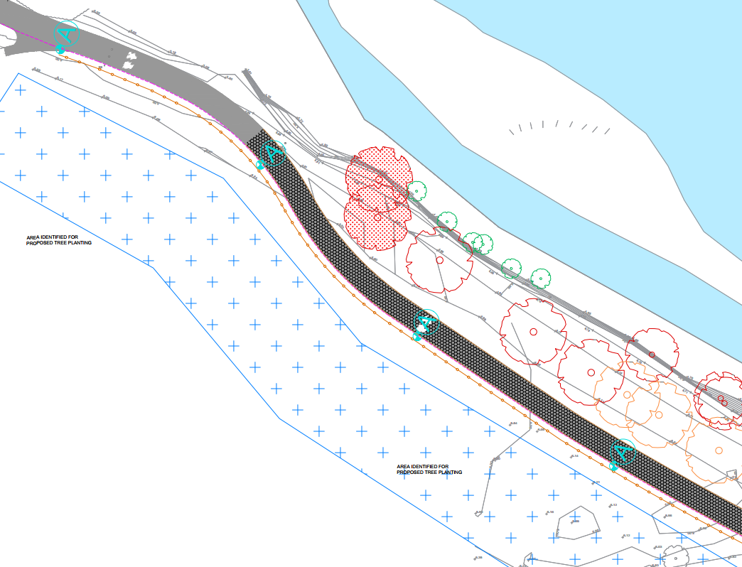
Bat roost
Bird roost
We carried out an invasive alien plant species survey along the proposed 6.8km greenway route and identified stands of Giant Hogweed and Himalayan Balsam along the riverbank. These areas will be spray treated with glyphosate before site clearance and the greenway path construction works commence. Invasive plant species along the riverbanks will be managed by LCCC on an ongoing basis after the greenway is operational.
Our water and hydrology assessment concluded the greenway will create no potential for significant effects on the quality of water in the Shannon and Mulcair rivers. We have also conducted an archaeological and built heritage assessment, and a landscape and visual impact assessment for the proposed greenway route.
The proposed greenway is highly adaptable to increasing flood risk due to climate change. OPW National Flood Hazard Mapping shows that most of the footprint of the proposed Greenway is within Flood Zone A and several historical flood events have been recorded in the area. However, on review of the ‘Planning System and Flood Risk Management’ Guidelines for Planning Authorities 2009), a cycle path or path falls under the category of development classified as “Amenity, open space, outdoor space and recreation” and is considered a flood compatible development. It is likely that the proposed greenway will experience flooding at times during the year but will remain in operation before and after these events. We have designed drainage measures to manage water off the greenway surface and will construct culverts under the greenway surface to channel surface water drainage towards the rivers.
We would like to express our sincere thanks to the Facilities team in the University, in particular Gerard Manning, who has enabled surveys and clearance works by our contractors, has continuously engaged with the design team to discuss various aspects of the design, and has helped define the proposed greenway route through the University campus.
We are currently finalising the design and we remain available to discuss any aspects of the design and next steps with the University.
Yours Sincerely,

